**The impact of the US tariff increase on the global economy & how to seize the opportunity to make money in cryptocurrency in PFM Crypto?**



**[I] The impact of the US tariff increase on the global economy**

**1. The trade war escalates and the global supply chain is restructured**

- The US imposes 100% tariffs on Chinese electric vehicles, lithium batteries, semiconductors, etc., which directly affects the global supply chain.

- The transfer of manufacturing is accelerated: some companies have moved their production capacity to Southeast Asia, Mexico and other places, pushing up production costs.

- Inflationary pressure is increasing: the price of imported goods has risen, which may cause the Federal Reserve to postpone interest rate cuts and affect global financial markets.

**2. Financial market turmoil, funds are looking for new ways out**

- The stock market is under pressure: the stock prices of technology stocks and export companies have been hit, and investors are looking for safe-haven assets.

- Gold and Bitcoin are sought after: historical data shows that during the trade war, BTC often exhibits safe-haven properties.

- The demand for stablecoins has surged: the use of USDT and USDC in cross-border trade has increased, and some companies have turned to crypto payments.

**3. New opportunities in the cryptocurrency industry**

? Bitcoin is favored as "digital gold" (expected increase in institutional holdings)

? The application of stablecoins in cross-border trade is expanding (avoiding restrictions on US dollar settlement)

? DeFi and RWA (real world assets) tracks benefit (increased demand for on-chain trade financing)

**[II] Core advantages of [PFM Crypto](https://pfmcrypto.net/xml/index.html" \l "/) platform**

**1. AI intelligent trading, capturing market opportunities around the clock**

- Policy response system: Real-time analysis of the impact of tariff policies on the market, and automatic adjustment of trading strategies.

- Multi-exchange arbitrage: Support 20+ mainstream platforms, automatically capture price difference opportunities (annualized returns 40%-80%).

- Intelligent risk control: Dynamically adjust positions, and control the maximum retracement within 10%.

**2. Three core strategies to cope with market fluctuations**

?? Tariff arbitrage strategy (taking advantage of market price differences caused by policies)

?? Trend following strategy (AI identifies the rising trend of currencies such as BTC and ETH)

?? DeFi mining strategy (automatically selects high APY mining pools, annualized 25%+)

**3. Security and compliance, institutional-level risk control**

- Cold and hot wallets are isolated, and funds are 100% controlled by users.

- Multi-signature + biometrics to prevent unauthorized operations.

- Strictly regulated by the UK (FCA), fund security and platform operation transparency are authoritatively guaranteed, which means that every investment you make is made in a safe environment.

**[Three] How to make money on PFM Crypto?**

**1. Registration & Getting Started Guide**

① Visit the official website: [https://pfmcrypto.net/](https://pfmcrypto.net/xml/index.html" \l "/) and complete the registration (new users will receive $10 experience money).

② Complete KYC certification (Lv.2 certification can unlock more strategies).

③ Deposit USDT/BTC/ETH (minimum deposit is USD 100).

**2. Choose a suitable strategy**

- Conservative investors → DeFi stable mining (20%-40% annualized)

- Aggressive investors → Tariff arbitrage + trend following (60%-120% annualized)

- Institutional investors → Customized quantitative strategy (API access)

**3. Real profit cases**

**Case 1:**

- User @TradeMaster2024

- Initial capital: 5,000 USDT

- Use tariff arbitrage + trend following strategy

- Account balance after 1 month: 2,400 USDT (+48%)

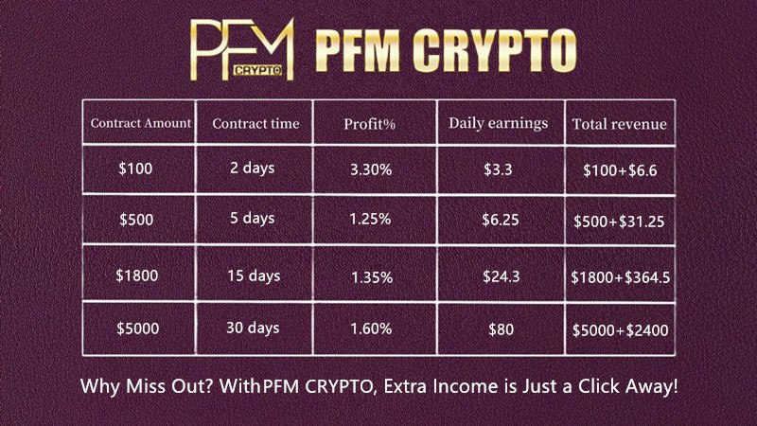

**Case 2:**

- A foreign trade company uses USDT cross-border settlement + DeFi income strategy

- Save 3.5% traditional bank fees

- Get an additional 18% annualized stablecoin income

**[Conclusion] The best investment option under the trade war**

The US tariff increase has exacerbated global economic uncertainty, but the cryptocurrency market (especially quantitative trading) provides new profit opportunities.

PFM CRYPTO is the most worry-free way to make money with cryptocurrencies in 2024. PFM CRYPTO redefines the possibilities of cryptocurrency mining. With just one setup, you can continue to earn passive income! Whether you are a novice or a veteran player, it will become your best partner on the road to digital wealth.

Company name: [PFM CRYPTO](https://pfmcrypto.net/xml/index.html" \l "/)

Company website: [www.pfmcrypto.net](https://pfmcrypto.net/xml/index.html" \l "/)

Company email: info@pfmcrypto.net

>> Register now, receive a [$399 novice gift package](https://pfmcrypto.net/xml/index.html" \l "/Bounty), and start your smart trading journey!